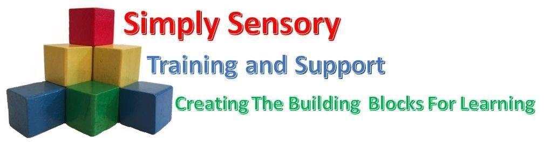
“Live, Laugh, Learn”

SIMPLY SENSORY
RISK ASSESSMENT POLICY

September 2022 - 2023

Reviewed: September 2022
Next Review Date: September 2023

This policy document should be read in conjunction with Simply Sensory’s Health and Safety Policy as required and where risk assessments are outlined in the Behaviour and Educational visits policies.
1. Introduction:
Documented Risk Assessments are a requirement under the Management of Health and Safety at Work Requirements 1999. Simply Sensory is required to assess the risks to health and safety of workers and any others who may be affected by the work carried out for the purpose of identifying measures needing to be taken to comply with other legislation. Carrying out these written assessments will help identify all the protective and preventive measures that must be taken to comply with the regulations.
It is the responsibility of Simply Sensory Management to ensure that risk assessments are in place. They can complete the assessments themselves, or instruct other staff to undertake them.
Simply Sensory will follow the Health and Safety Executive’s 5 stage approach to Risk Assessments:
Step 1 – Identify the hazards.
Step 2 – Identify who might be harmed and degree of severity.
Step 3 – Evaluate the risks and decide on precautions.
Step 4 – Record and implement findings.
Step 5 – Review assessment and update if necessary.
Copies of the individual learners home environments are completed before Simply Sensory commence working with the learner in their home. These should be in date and signed by the Assessor and the responsible person undertaking the tasks. Risk assessments will be reviewed regularly or as the needs of the learner changes. All staff working within the home should have access to these documents with copies available to Health and Safety, Designated Safeguarding Lead (DSL), Education Monitoring Officers who will ensure they are available for inspection by the HSE, and the outside inspectors as required.
Risk assessments should be reviewed and revised as follows:
Environmental site risk assessments should be reviewed annually or sooner if circumstances change.
When there is reason to suspect the assessment is no longer valid. This may become apparent through accidents and near misses, safety complaints, ill-health trends, or the management team may become aware that a relevant piece of legislation has fallen out of date.
When there has been a significant change in the matters to which the assessment relates, such as the introduction of new work equipment, changes in management personnel, and a change in the learners' needs.

Educational Visits:
Before any educational visit a detailed risk assessment is completed by an experienced Simply Sensory team member or management. This will be checked by management and shared with and agreed to by any staff member supporting the visit. All significant findings should be recorded and brought to the attention of relevant personnel, with signatures provided as evidence that the information has been read and received by those undertaking the tasks or specific staff that are supporting pupils on off-site activities. Copies are sent to Education Monitoring Officers or individual schools and settings.
Simply Sensory have the following Risk Assessments in place:
Risk Assessment templates
Risk Assessments for individual pupils and their home environment
Individual Educational visits assessments
Complex medical condition assessments
All the above have specific templates that will assist in the completion of the task; these need to be signed off by Simply Sensory Management DSL
2. Other Types of Risk Assessment
Generic Risk Assessments are acceptable where activities/processes/operations are consistent across the workplace. However, these must be adapted, as appropriate, to consider particular individuals and specific issues relating to the environment.
Dynamic Risk Assessments are constant, on the spot assessments of the situation/task that are not written down. These should not be relied on completely for a task, as there is no written evidence of the control measures in place. Dynamic risk assessments alone will not be accepted by the HSE in any accident investigation. However they can be noted in a full Risk Assessment as an on-going assessment of the risk or reference outlined set procedures and practices adopted in the environment.
Educational visit assessments need to be individually planned for every visit and specific considerations will include the needs of the pupils, staff ratios, environmental factors and choice of activity in relation to the individual or group of the pupil/pupils Social Emotional and Mental Health (SEMH) difficulties.
Nature of Risk Assessments:
Assessments identify significant risks and prescribe remedial action, i.e. risk control measures.
Thorough risk assessment we resolve to answer such questions as the following:
What hazards are we faced with?
Who might be affected?
How can the risks be reduced to an acceptable level?
Can effective measures be implemented now?
If not, what contingency plans will serve us best for the time being?
Pastoral:
The focus of our pastoral care is to ensure that each pupil becomes a confident, articulate young adult capable of keeping him/herself safe whether at home or outside the home.
Safeguarding:
Our Safeguarding Policies and training for all staff form the core of our Child Protection Risk management. Safe recruitment policies and procedures ensure that the Simply Sensory is not exposed to the risk of employing staff who are barred from working with children, or who are not allowed to work in the UK.
Sensory behaviours risk assessments:
Our learners have individual sensory needs which may impact on their everyday life and behaviours. To support these Simply Sensory produce and follow:
One Page Sensory Profiles with sensory aversions and preferences listed where appropriate
CASP (Consistent Approaches to Support Pupil Plan) where appropriate
These plans ensure that staff working with the child have a greater understanding of the pupils individual needs and sensory behaviours and give a consistent and appropriate response to support them.
Attached are the following black assessments templates:
- Behaviour Concern Form
- One Page Sensory Profile
- CASP
- Home Tuition Risk Assessment
- Educational Visit Risk Assessment

Behaviour Concern Form
Pupil name: | Date of concern:
Name of person making concern: | People present:

Brief description of concern/behaviour observed and possible triggers
Response to situation /action taken:
Future action/support:
Date for Next Review: | / /

HOME TUTORING RISK ASSESSMENT::

Establishment: Simply Sensory Training and Support Name: Helen Dillon Julie Cowpe-Stephens Date of assessment:
The following assessment relates to the risks observed by working with a specific learner within their own home.

ASSESSMENT OF SPECIFIC SIGNIFICANT HAZARDS:

Hazard/Activity | Initial risk rating | Persons at risk | Risk | Control measures in use | Residual risk rating  H/M/L | Further Action Required  Yes No

ASSESSMENT CARRIED OUT BY (NAME): SIGNED: DATE:

EDUCATIONAL VISIT RISK ASSESSMENT:

Establishment: Simply Sensory Training and Support Name: Helen Dillon Julie Cowpe-Stephens Date of visit:
Description of the location and nature of visit/activity:

ASSESSMENT OF SPECIFIC SIGNIFICANT HAZARDS:

Hazard/Activity | Initial risk rating | Persons at risk | Risk | Control measures in use | Residual risk rating  H/M/L | Further Action Required  Yes No

ASSESSMENT CARRIED OUT BY (NAME): SIGNED: DATE:

